* Screenshot of Model Plot
  + 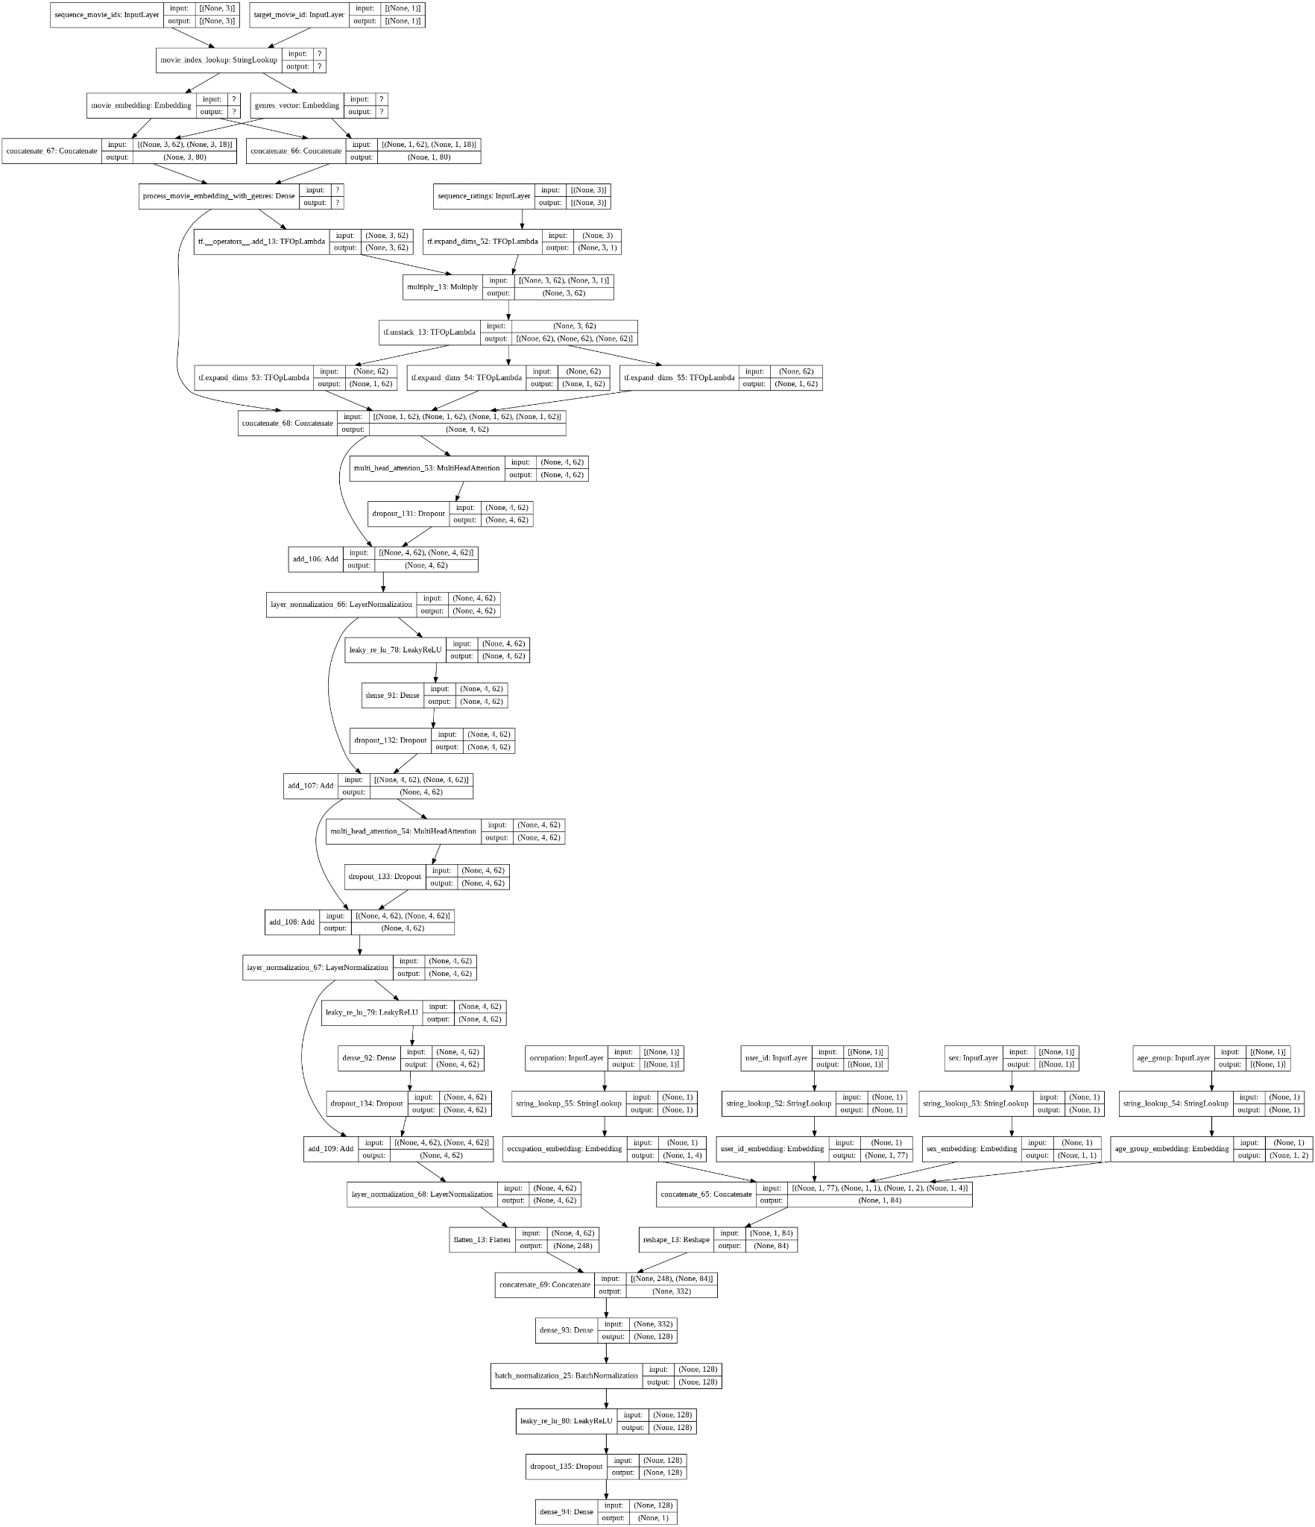
* Screenshot of Test RMSE:
  + 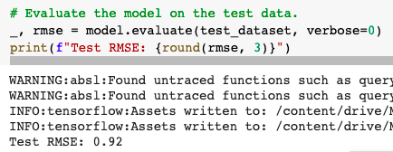
* Screenshot of Model Train and Val Plt plot:
  + 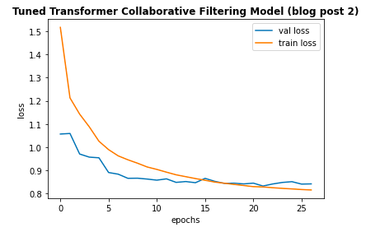
* Parameters:
  + 2 transformer blocks
  + 8 heads (multi-attention)
  + Lr = 0.02, Adagrad optimizer
  + include_user_id = True
  + include_user_features = True
  + include_movie_features = True
* Tensorboard:
  + Link to Tensorboard:
  + Screenshot of Tensorboard
* Ratings Predictions and Movies Recommendation Using Trained Baseline Model
  + Movie Ratings Prediction of User with ID = 2000
  + Recommended Movies for User with ID = 2000 based on Predicted Ratings